Create a SARCC Fundraiser on Facebook

Here’s an example of a SARCC fundraiser on Facebook:
https://www.facebook.com/donate/664121998131992/

HOW IT WORKS
- Create a fundraiser: All the tools and tips you’ll need are outlined below. (Remember: Facebook does not charge fees on fundraisers for nonprofits. That means 100% of the funds you raise go straight to SARCC)
- Share with friends: Connect your friends and family to SARCC, gain supporters across Facebook, and watch your impact grow.
- Get donations: People can donate to your Fundraiser in just a few clicks, without ever leaving Facebook.
HOW TO CREATE YOUR FUNDRAISER in less than three minutes:

- Step 1
  - Download our customized FB cover photo. Click here to download a cover photo to use.
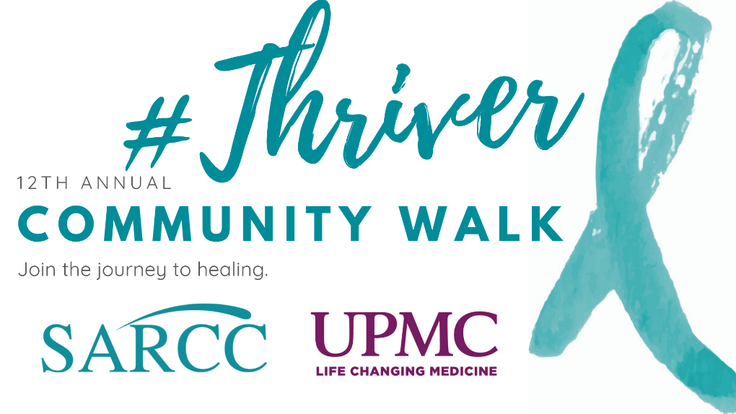
  - Save to your desktop
- Step 2
Login to your Facebook and click the Grid button. Select Fundraiser.
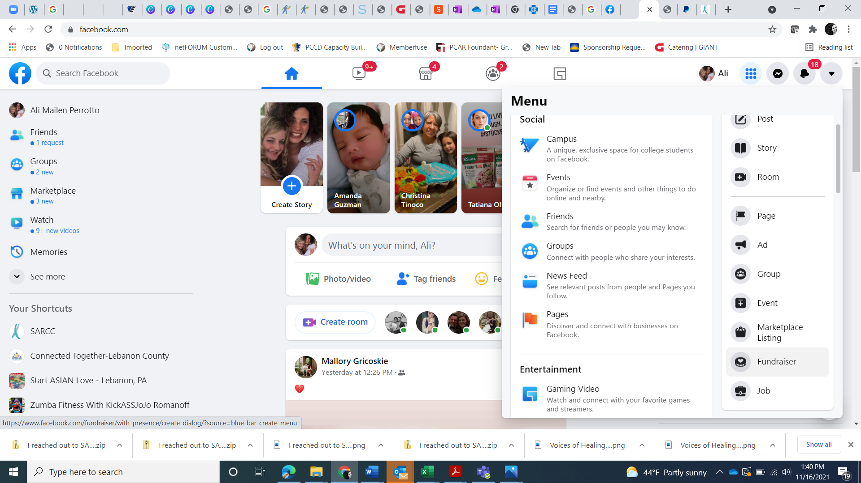
- Step 3
Choose a Fundraiser Cause. Click the Nonprofit button to search for SARCC.
- 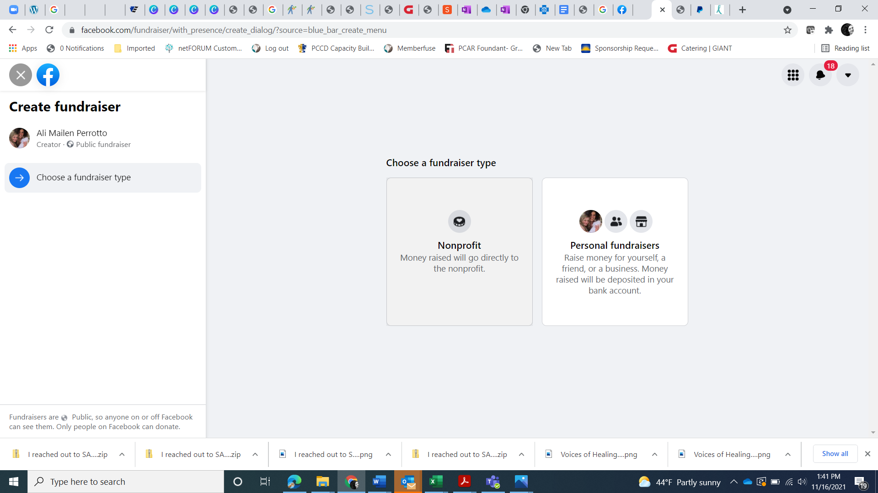
- Step 4
Search for “Sexual Assault Resource & Counseling Center of Lebanon & Sch”
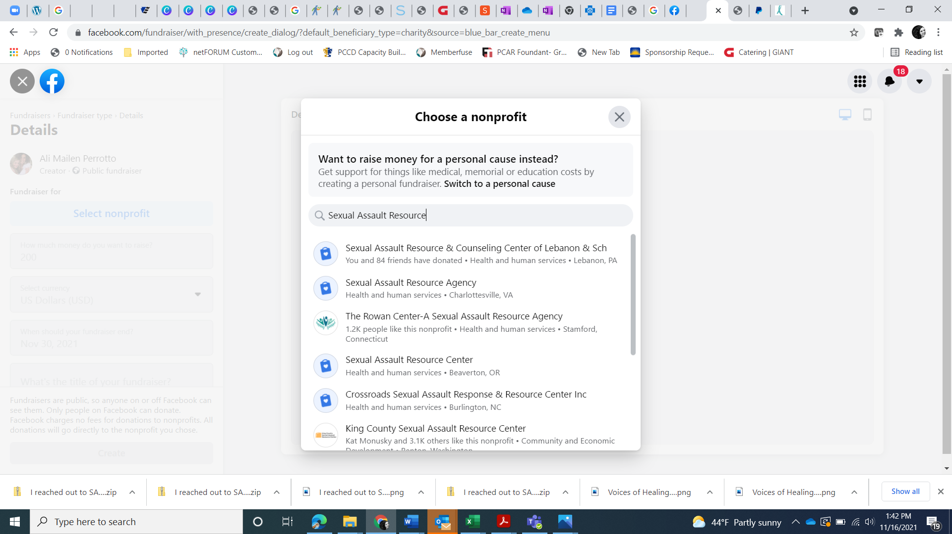
- Step 5
Fill in your fundraiser details. #ThriverWalk is June 5 and the Virtual Walk Challenges will begin in the first week of April. Any time between April 1 and June 5 is a great time to kick-off your fundraiser. Since the event is partnered with Summer Fest, it can help to bring awareness to your fundraiser if you tag Better Together, Summer Fest, or SARCC when you post about it and your Facebook friends may be more willing to give. However, any time you want to run your Facebook fundraiser is great!
- 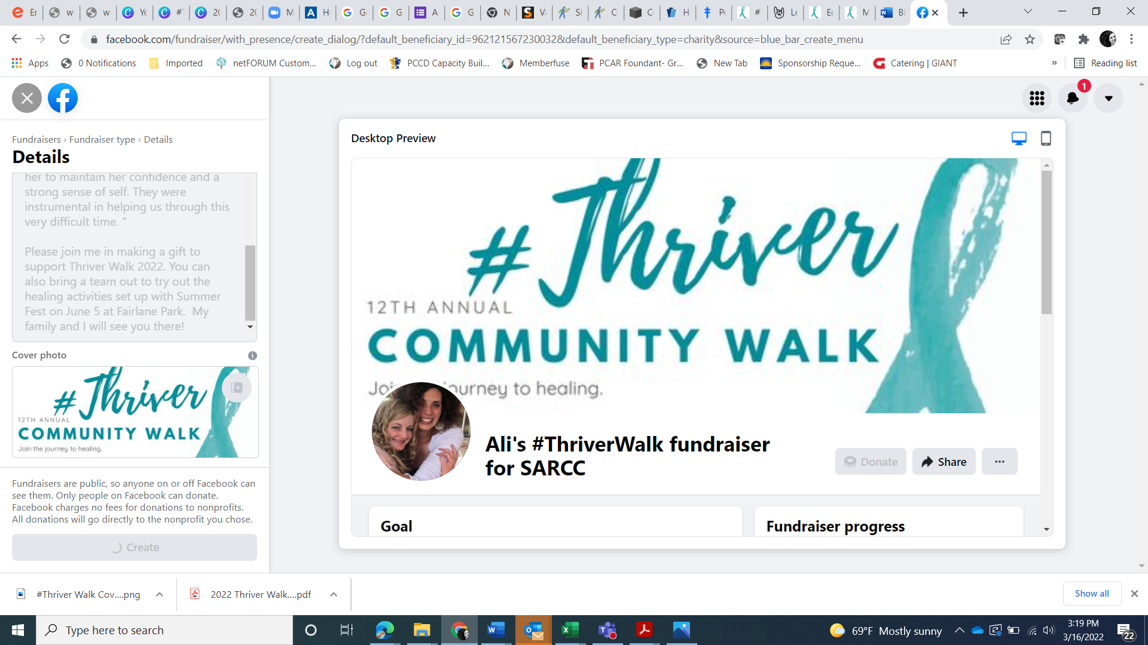
- In the left box, scroll down to update and personalize your fundraiser and details.
  - Set the Dollar Amount you want to raise
  - Select Currency (US Dollars)
  - Set End Date (i.e. Dec. 31)
  - Enter the title of your fundraiser
    - Fundraiser Title Examples:
      - [Your Name’s] #ThriverWalk Fundraiser for SARCC
      - Support Survivors’ Voices of Healing
      - Prevention is Possible: Give hope for survivors
  - Why are you raising money?
Feel free to copy and paste a sample script. Also feel free to change any part of the script or titles to make them authentic for you. If you have a personal story about SARCC, please make sure to add it!
SARCC Script Examples
Fundraiser Script Example 1:
Survivors of sexual violence NEVER choose to be in this position. They CAN choose how they heal from it. When they choose to work with SARCC on their healing, survivors of sexual violence get a partner who believes their story, sees their strength, and works together with them to find the path to healing.

This is really important to me because in Lebanon and Schuylkill Counties survivors have 24-hour support. This includes no-cost counseling and therapy, and prevention education in our community.

[If you have a personal story about SARCC, you can share it here.]

I’m asking you to help me support SARCC and the survivors they serve by donating to my goal.

The need is greater now than ever before. So many in our community are struggling with past or current victimizations. SARCC believes in the power of each survivor to heal and thrive. They need your help to continue providing these important and needed free services for the children and adults of our county.

Thank you for your support!

Script 2 sample:
Fundraiser Script Example 2:
Did you know that in any given classroom, 5 out of 25 kids will experience sexual abuse? So many children and adults in our community are healing from childhood trauma. As a participant in #ThriverWalk for SARCC, I want to share these quotes from survivors with you:

"I came to SARCC at the recommendation of my doctor after experiencing continuing sexual harassment at work, which caused me to resign from my job. My counselor at SARCC has been the only reason I get up in the morning understanding the experience I went through. I was reluctant to start counseling since I never did it and didn't believe it would help me. It did. I encourage anyone who has or is experiencing any type of sexual harassment to see a counselor at SARCC to help them start a new, healthier life."

"My daughter was assaulted by someone she trusted. SARCC helped her through the trauma and helped her to maintain her confidence and a strong sense of self. They were instrumental in helping us through this very difficult time. "

"I reached out to SARCC for help in preparing the victim to testify at the preliminary hearing as the victim is experiencing high levels of trauma. The SARCC Advocate has consulted with me several times and even made the trip to our county yesterday to assist the victim at the hearing. It is my belief that the victim would have been unable to testify without the support of SARCC. The victim began to dissociate prior to the hearing. The advocate jumped in, got her re-grounded, and she successfully testified."

I’m asking you to donate to SARCC in honor of a survivor in your life or in recognition of the thousands of local survivors SARCC has served over the years.
You can donate right now. Every penny of your donation goes directly to SARCC. Learn more about SARCC at sarccheals.org.

Thank you for your support!

- Step 7
Upload your customized cover photo (the one you saved to your desktop in step 1) to Facebook.
- Click Create
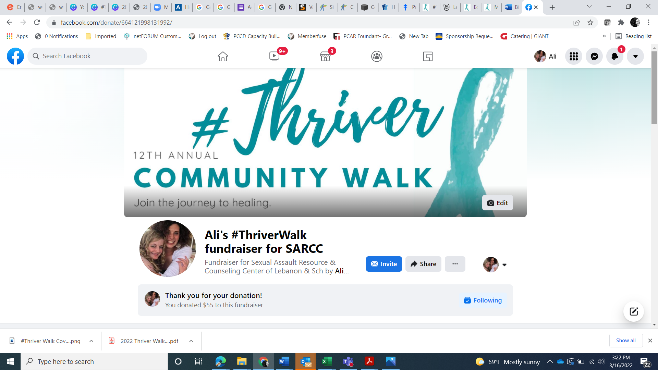

WHAT NEXT?

Share your fundraiser with the world! You want to motivate and inspire your friends and family to donate. That means educating and telling your story of why SARCC matters to you.

The easiest way to get people involved is to directly invite them to the fundraiser. Don’t assume everyone can see that you’ve created a fundraiser-- not everyone sees everything their friends post on Facebook anymore! Inviting them ensures they will receive a message nudging them to participate.

Remember that your Facebook and social media fundraising efforts count toward yours or your teams’ Thriver T-shirts. Individuals who raise $50, or Teams of up to 10 people who raise $500 get a Thriver Walk T-shirt!

When people donate, make sure that you thank them in the comments of their donation. This will generate more interest in the fundraiser. The more you share the fundraiser and comment in the fundraiser, the more visible it will be to other people

You will also want to share your Fundraiser on Facebook, too. Here are some sample posts you can share on Facebook to spark engagement:

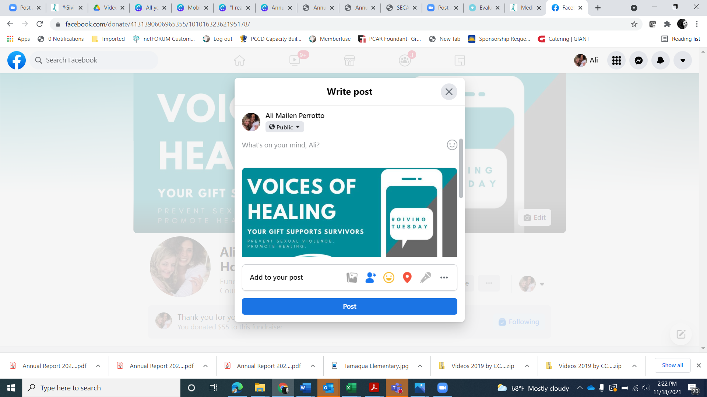

- ANNOUNCEMENT
June 5 SARCC will hold their 12th Annual Walk event with #ThriverWalk at Summer Fest! In honor of Sexual Assault Awareness Month in April, I’m fundraising for SARCC! Every dollar I raise will be used to help provide free, needed services to kids and adults surviving trauma in our community. Learn more and show your support here: [link to your FB fundraiser]

- REMINDER/IMPACT DETAILS
[X] days until #ThriverWalk. Now through June 5th, I’m fundraising for SARCC of Lebanon & Schuylkill Counties, a local mental health non-profit. Learn more here: [link to your FB fundraiser]

- June 5, 2022
Can you help me get to my fundraising goal? Donate Now. Learn more and donate here:[link to your FB fundraiser]

TAKE IT OFFLINE
Get your friends and family excited about your SARCC fundraiser through email. Copy and customize this sample text:

- ANNOUNCEMENT
Dear [Name],
I have exciting news! In honor of #SAAM and #ThriverWalk, I’m fundraising for SARCC of Lebanon & Schuylkill Counties, a local non-profit that provides 24-hour crisis counseling, support, and therapy services. I’m passionate about one of their programs: Parents In The Know. This program helps adults in our community learn the skills they need to prevent sexual abuse against children.
You know how important it is to ensure that our kids have a great start to life. Your donation--in any amount-- would help provide needed prevention and support services to our community. Learn more and make a donation here [link to your FB fundraiser].
Thank you for your support!
[Your name]

- REMINDER/IMPACT DETAILS
Dear [Name],
SARCC’s annual #ThriverWalk is around the corner and I need your help in supporting SARCC, a local non-profit providing healing services to survivors of sexual violence. They also provide powerful prevention programs in our community.
Please consider making a donation to SARCC on Facebook now, on #ThriverWalk Day, or as part of your commitment to supporting survivors of sexual abuse. Every dollar I raise will be used to get much-needed services to our area. Learn more and make a donation here [link to your FB fundraiser].
Thank you for your support.
[Your name]

- June 5
Dear [Name],
Ready...set...go! Today is #ThriverWalk, part of the Summer Fest activities that center, health, healing, and community. I’m passionate about SARCC. I’ve been raising funds for their prevention and healing services. You can help by making a donation here [link to your FB fundraiser]. Every dollar I raise will go to SARCC, supporting survivors and preventing violence and trauma.
I greatly appreciate your support and commitment to making a difference in the lives of survivors. Learn more and donate now [link to your FB fundraiser].
Sincerely,
[Your name]

FOLLOW UP

After #ThriverWalk, please consider reporting and celebrating the impact your friends’/family’s donations. Post a thank you note on Facebook or mail handwritten notes to your donors.

-------------------------------

About SARCC
SARCC’s mission is to prevent sexual violence and promote healing. The organization provides no-cost, confidential crisis counseling and intervention to survivors of sexual violence and their friends and family members 24 hours a day, including hotline support, counseling, therapy, advocacy, and accompaniment. They have provided sexual assault services in Lebanon County since 1983 and in Schuylkill County since 2009. Their services emphasize the importance of meeting the client where they are to facilitate connection to healing and supportive services.
Services are provided by a combination of SARCC Staff, hotline volunteers, and medical advocacy volunteers, who work collaboratively to provide a continuum of client services that respond to the needs of victims of sexual violence and their significant others. This form of victimization has both short and long-term impacts that affect the physical, mental, and emotional well-being of the survivors they serve (Black et al, 2011; Felliti et al, 1998). In the moment, with a survivor, SARCC creates a warm and supportive connection which allows people experiencing an incredibly difficult time to connect and find the path for healing that will best meet their needs.
SARCC offices are fully accessible, and the staff travel throughout the county to provide services to their clients. In the past five years, SARCC has enhanced services and collaborations to better support survivors, including providing services for survivors with co-occurring challenges, like drug and alcohol use, mental health issues, and involvement with other systems. This includes providing onsite support groups and counseling at colleges, the Children’s Resource Center, treatment facilities, and Correctional Facilities in both counties.

SARCC serves survivors of sexual violence and their significant others through direct services. Counseling and therapy services are offered to children as well as adults. The organization also provides community education on preventing sexual violence. The past few years, this has included a special focus on the prevention of child sexual abuse. To prevent this violence, SARCC expanded programming to work with adults in our community through Parents in the Know programs for parents and caregivers, Mandated Reporting training for professionals, community members, and volunteers working with children, and trauma-informed classrooms training for teachers and daycare providers.

