Create a SARCC Fundraiser on Facebook

Here’s an example of a SARCC fundraiser on Facebook: https://www.facebook.com/donate/686704152195485/10101404567238098/

HOW IT WORKS
- Create a fundraiser: All the tools and tips you’ll need are outlined below. (Remember: Facebook does not charge fees on fundraisers for nonprofits. That means 100% of the funds you raise go straight to SARCC)
- Share with friends: Connect your friends and family to SARCC, gain supporters across Facebook, and watch your impact grow.
- Get donations: People can donate to your Fundraiser in just a few clicks, without ever leaving Facebook.
HOW TO CREATE YOUR FUNDRAISER in less than three minutes:

- Step 1
1. Download our customized FB cover photo. Click here to download a cover photo to use.
2. Save to your desktop
- Step 2
Login to your Facebook and click the + button. Select Fundraiser.
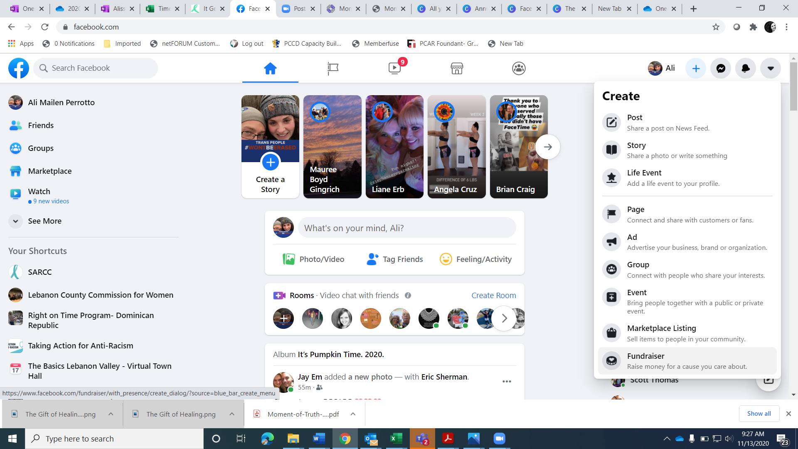
- Step 3
Choose a Fundraiser Cause. Click the Nonprofit button to search for SARCC.
- 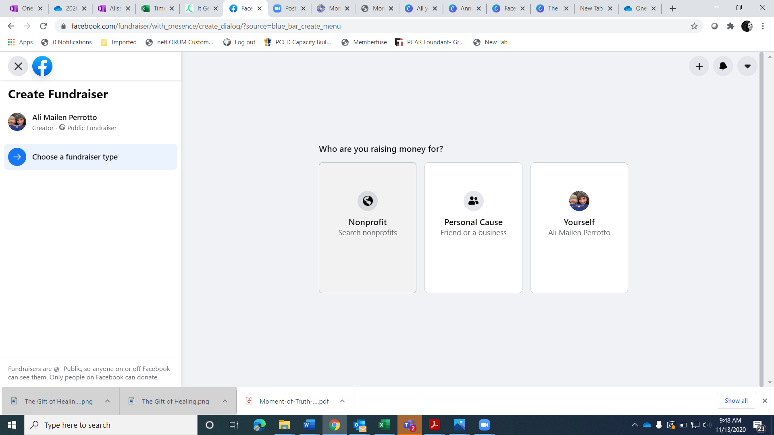
- Step 4
Search for “Sexual Assault Resource & Counseling Center of Lebanon & Sch”
- Step 5
Fill in your fundraiser details. The 2021 #ThriverWalk is June 5 and Sexual Assault Awareness Month is in April, so you can create for fundraiser any time between April 1 and June 30 to support the effort. Stimulus checks and tax returns are a opportunity for making charitable donations, and you can mobilize your own circles to give to a good cause locally. However, any time you want to run your Facebook fundraiser is great!
  - Set the Dollar Amount you want to raise
  - Select Currency (US Dollars)
  - Set End Date (i.e. Dec. 31)
  - Enter the title of your fundraiser
    - Fundraiser Title Examples:
      - [Your Name’s] #GivingTuesday Fundraiser for SARCC
      - Give The Gift of Healing to Survivors
      - Prevention is Possible: Give hope for survivors
  - Why are you raising money?
Feel free to copy and paste a sample script. Also feel free to change any part of the script or titles to make them authentic for you. If you have a personal story about SARCC, please make sure to add it!
SARCC Script Examples
Fundraiser Script Example 1:
Nobody chooses sexual violence, but they can choose how they heal from it. We know that healing is possible. There’s a program in Lebanon and Schuylkill Counties that provides 24-hour support to survivors and their families, no-cost counseling and therapy, and prevention education in our community.

This is really important to me because...

[If you have a personal story about SARCC, share it here.]

This year for #SAAM and #ThriverWalk, I’m asking you to help me support SARCC and the survivors they serve by donating to my goal.

The need is greater now than ever before. So many in our community are struggling with past or current victimizations. SARCC believes in the power of each survivor to heal and thrive. They need your help to continue providing these important and needed free services for the children and adults of our county.

Thank you for your support!

Script 2 sample:

"A revolution always begins from within. This one begins when you decide how you will hold the issues of sexual assault, domestic violence and child abuse within you, and how you live out that decision." ~Mariska Hargitay

Sexual violence is a common and widespread issue that impacts our community every day. In any given classroom of 25 children, five of them will experience sexual victimization before they turn 18 based on national victimization rates. This is an issue that impacts people of all ages, genders, and neighborhoods. There are over 23 million survivors of sexual assault in the United States, and it is time to say "NO MORE" to this crime in our community.

I am asking my friends and family to join my efforts to prevent sexual violence and promote healing in Lebanon County by donating to my own virtual #ThriverWalk! The in-person walk is on June 5, but I’m raising funds online up until then to support local survivors. Join me by promoting better health, greater opportunities for healing, and resilient futures for every survivor. Thank you for your support!

Script 3 sample:
Did you know that in any given classroom, 5 out of 25 kids will experience sexual abuse? So many children and adults in our community are healing from childhood trauma. As a board member of SARCC, I recently read a letter written by a survivor who used our services. I want to share that letter with you:

“As a result of being vulnerable during therapy and counseling, I am feeling night-to-day better about myself and my life, I am more accepting of the various aspects of myself, and I have more coping tools in my toolbox to help me when I am feeling scared or depressed. The collaboration with SARCC has helped me grow and heal in ways that I never imagined possible.
If you are wondering if it is worth the pain and discomfort to work through your traumatic life experiences, the answer is a resounding, “Yes.” With the guidance of SARCC staff, you will receive emotional support unlike any other. The SARCC staff provides lengthy sessions and even in-between connection via email, phone calls, or their crisis line if needed to help you through difficult times. You have an opportunity of a lifetime to transform yourself from being a victim, to being not only a survivor but someone who thrives. SARCC staff will help facilitate and guide your healing process to match your needs and timing. What are you waiting for?”

This #SAAM, I’m asking you to donate to SARCC in honor of a survivor in your life or in recognition of the thousands of survivors we have served over the years.
You can donate right now. Every penny of your donation goes directly to SARCC-- there are no processing fees. Learn more about SARCC at sarcclebanon.org.

Thank you for your support!

- Step 7
Upload your customized cover photo (the one you saved to your desktop in step 1) to Facebook. You can also create your own photo if you prefer! We love creativity that supports a good cause!
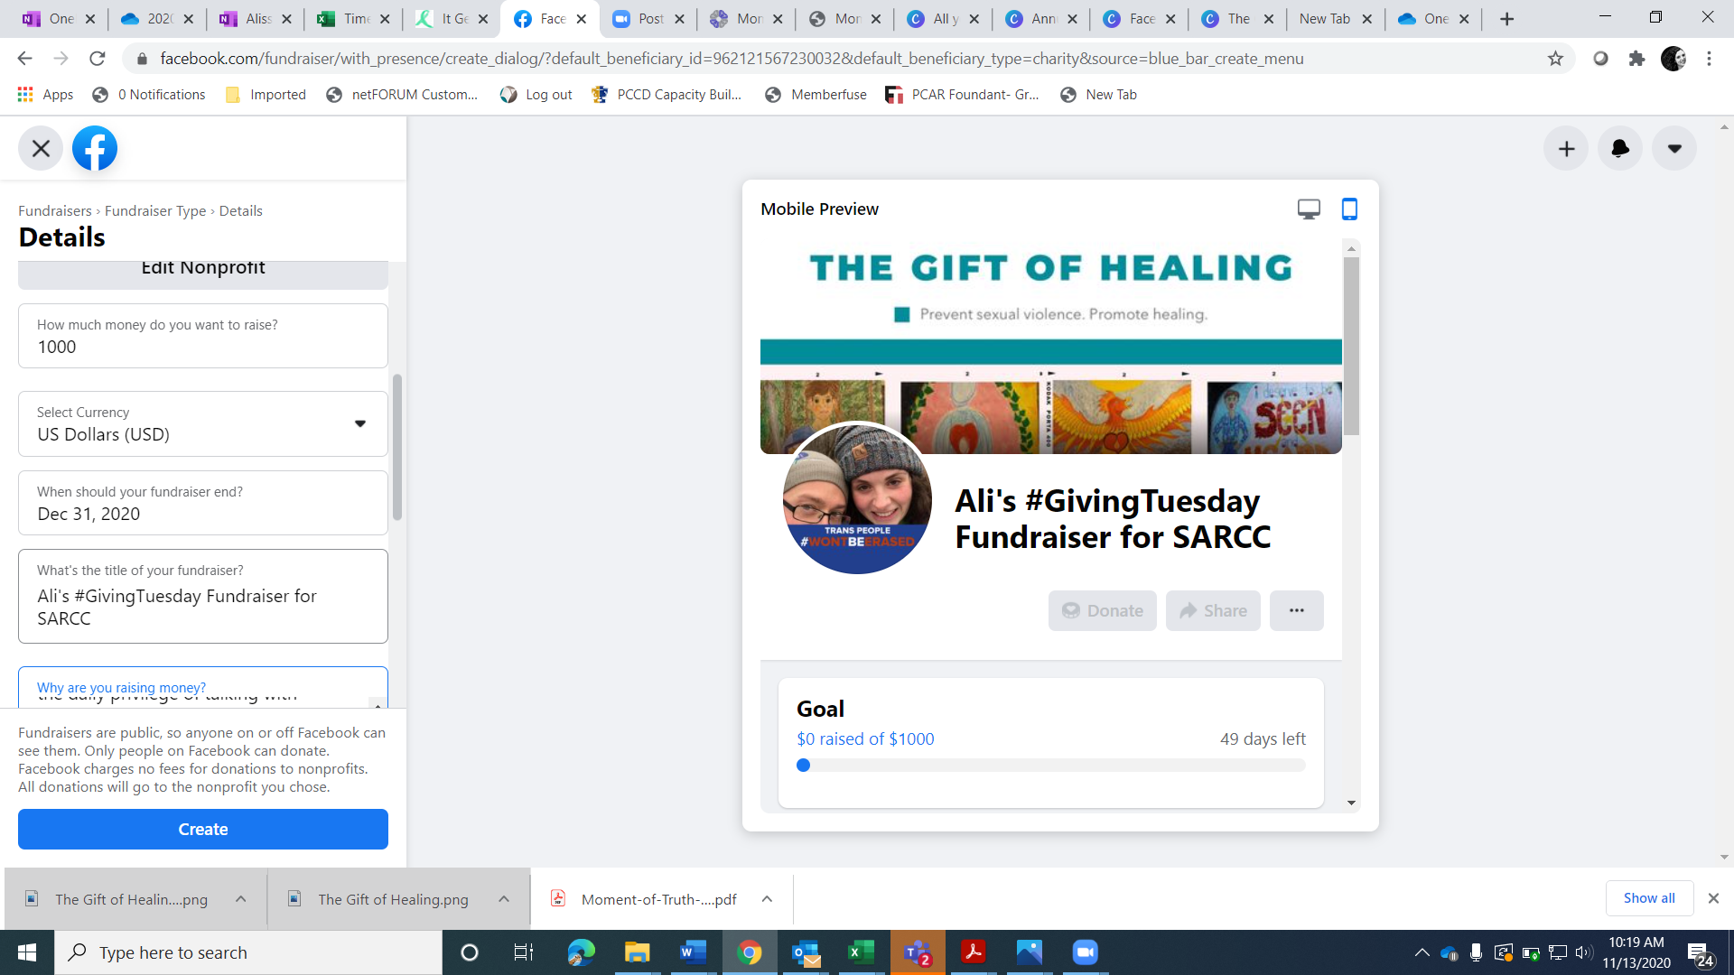
- Click Create

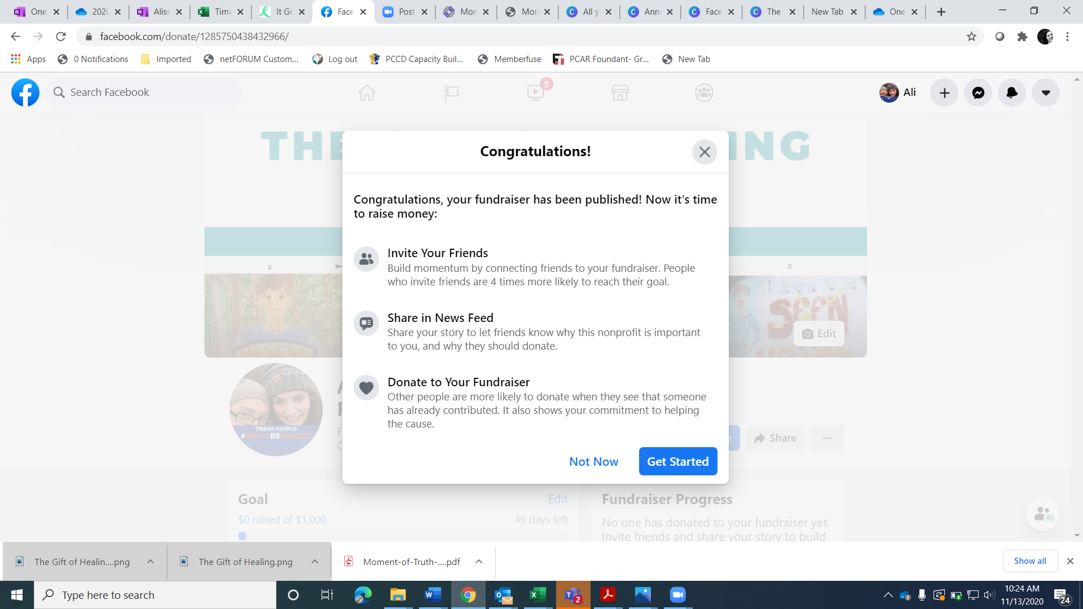

WHAT NEXT?

Share your fundraiser with the world! You want to motivate and inspire your friends and family to donate. That means educating and telling your story of why SARCC matters to you.

The easiest way to get people involved is to directly invite them to the fundraiser. Don’t assume everyone can see that you’ve created a fundraiser-- not everyone sees everything their friends post on Facebook anymore! Inviting them ensures they will receive a message nudging them to participate.

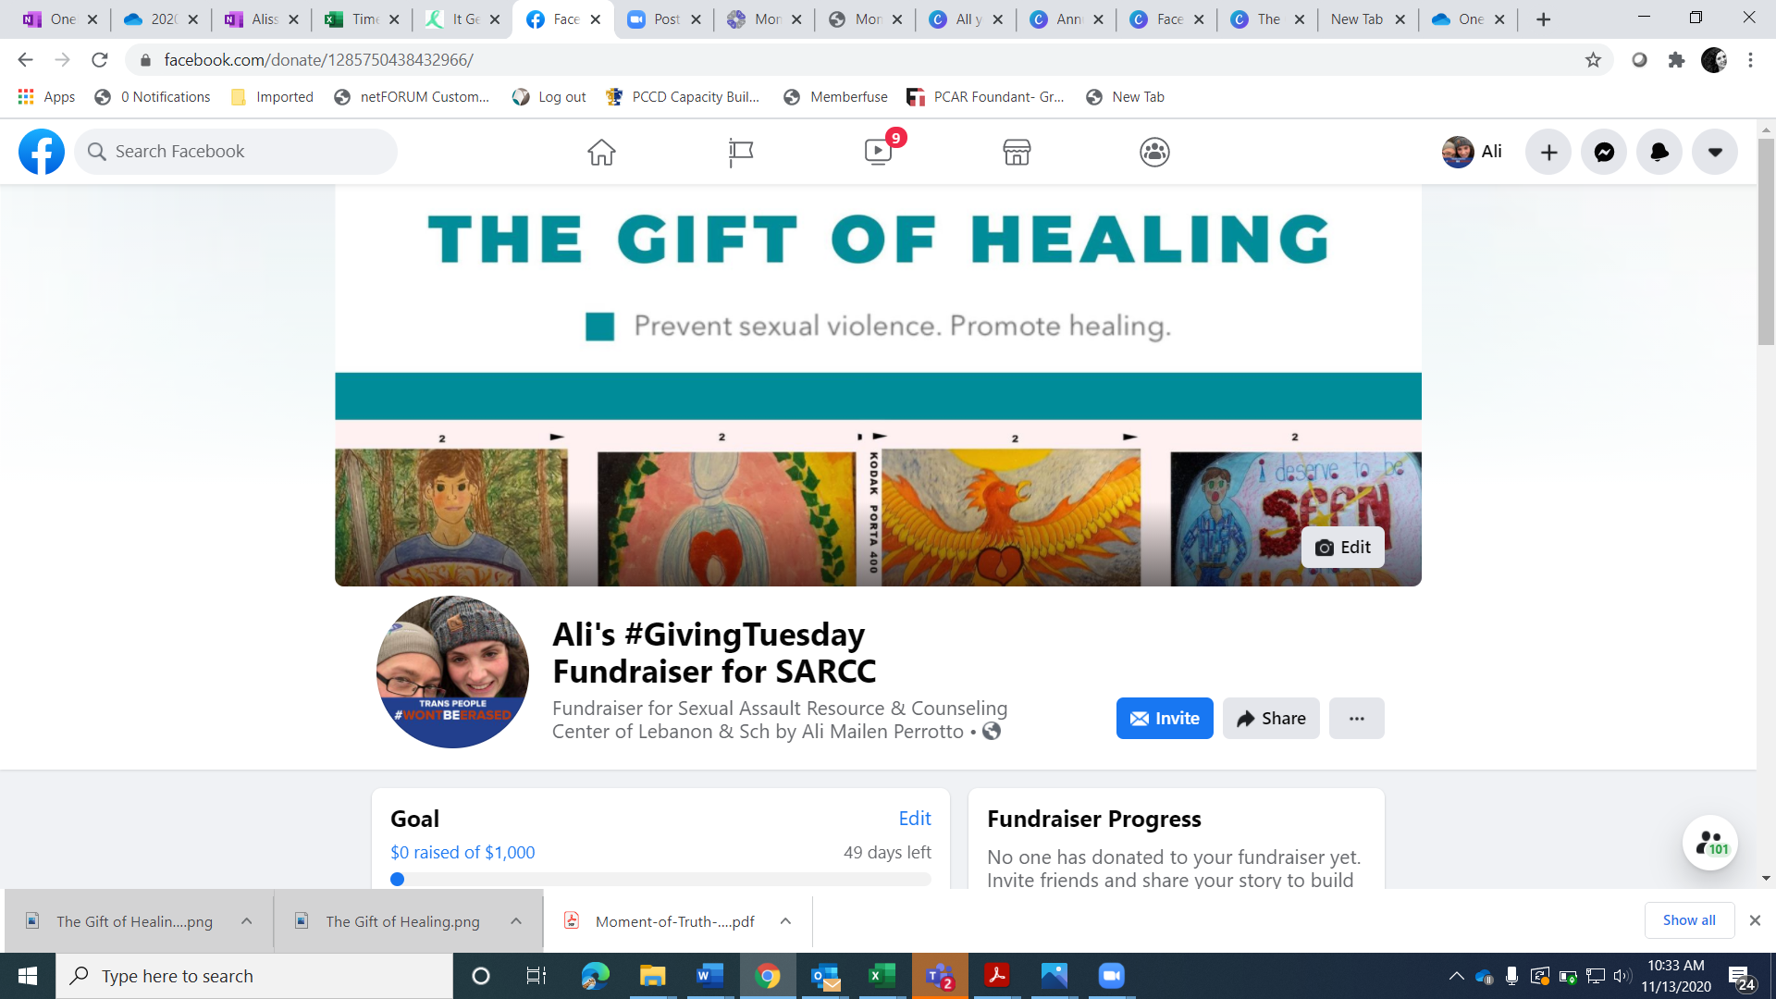

When people donate, make sure that you thank them in the comments of their donation. This will generate more interest in the fundraiser. The more you share the fundraiser and comment in the fundraiser, the more visible it will be to other people

You will also want to share your Fundraiser on Facebook, too. Here are some sample posts you can share on Facebook to spark engagement:

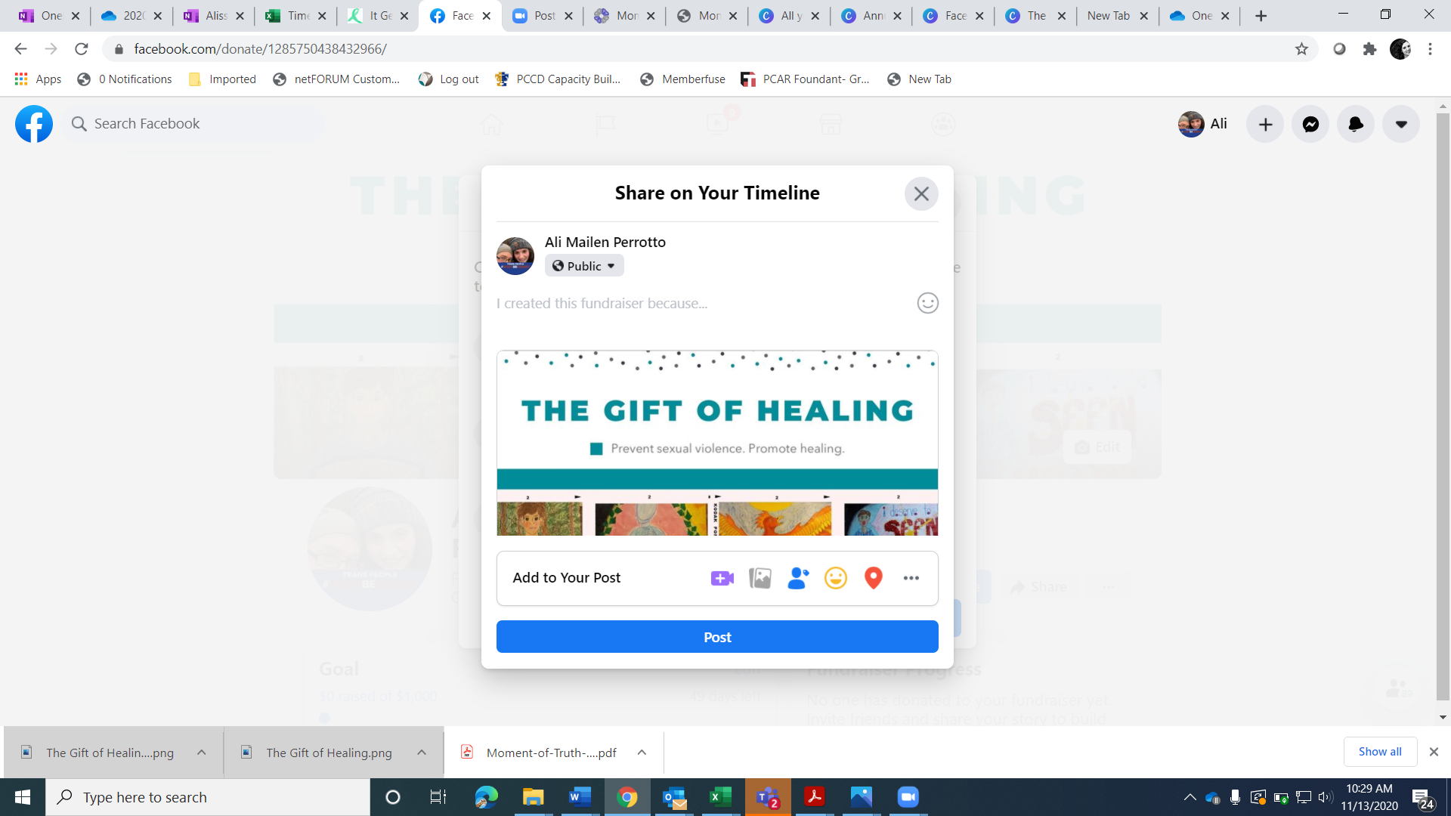

- ANNOUNCEMENT
December 1 is #GivingTuesday and this year I’m fundraising for SARCC! Every dollar I raise will be used to help provide free, needed services to kids and adults survivor trauma in our community. Learn more and show your support here: [link to your FB fundraiser]

- REMINDER/IMPACT DETAILS
[X] days until #GivingTuesday. Now through [DATE] , I’m fundraising for SARCC of Lebanon & Schuylkill Counties, a local mental health non-profit. Learn more here: [link to your FB fundraiser]

- June 5
Can you help me get to my fundraising goal? Donate Now. Learn more and donate here:[link to your FB fundraiser]

TAKE IT OFFLINE
Get your friends and family excited about your SARCC fundraiser through email. Copy and customize this sample text:

- ANNOUNCEMENT
Dear [Name],
I have exciting news! In honor of #GivingTuesday, I’m fundraising for SARCC of Lebanon & Schuylkill Counties, a local non-profit that provides 24-hour crisis counseling, support, and therapy services. I’m passionate about one of their programs: Parents In The Know. This program helps adults in our community learn the skills they need to prevent sexual abuse against children.
You know how important it is to ensure that our kids have a great start to life. Your donation--in any amount-- would help provide needed prevention and support services to our community. Learn more and make a donation here [link to your FB fundraiser].
Thank you for your support!
[Your name]

- REMINDER/IMPACT DETAILS
Dear [Name],
#ThriverWalk is around the corner and I need your help in supporting SARCC, a local non-profit providing healing services to survivors of sexual violence. They also provide powerful prevention programs in our community.
Please consider making a donation to SARCC on Facebook now, on #ThriverWalk Day (June 5th), throughout the summer months. Every dollar I raise will be used to get much-needed services to our area. Learn more and make a donation here [link to your FB fundraiser].
Thank you for your support.
[Your name]

- June 5th
Dear [Name],
Ready...set...go! Today is #ThriverWalk Day, a day to celebrate hope and healing for survivors of sexual abuse. I’m passionate about SARCC. I’ve been raising funds for their prevention and healing services. You can help by making a donation here [link to your FB fundraiser]. Every dollar I raise will go to SARCC, supporting survivors and preventing violence and trauma.
I greatly appreciate your support and commitment to making a difference in the lives of survivors. Learn more and donate now [link to your FB fundraiser].
Sincerely,
[Your name]

FOLLOW UP

After #ThriverWalk, please consider reporting and celebrating the impact your friends’/family’s donations. Post a thank you note on Facebook or mail handwritten notes to your donors.

-------------------------------

About SARCC
SARCC’s mission is to prevent sexual violence and promote healing. The organization provides no-cost, confidential crisis counseling and intervention to survivors of sexual violence and their friends and family members 24 hours a day, including hotline support, counseling, therapy, advocacy, and accompaniment. They have provided sexual assault services in Lebanon County since 1983 and in Schuylkill County since 2009. Their services emphasize the importance of meeting the client where they are to facilitate connection to healing and supportive services.
Services are provided by a combination of SARCC Staff, hotline volunteers, and medical advocacy volunteers, who work collaboratively to provide a continuum of client services that respond to the needs of victims of sexual violence and their significant others. This form of victimization has both short and long-term impacts that affect the physical, mental, and emotional well-being of the survivors they serve (Black et al, 2011; Felliti et al, 1998). In the moment, with a survivor, SARCC creates a warm and supportive connection which allows people experiencing an incredibly difficult time to connect and find the path for healing that will best meet their needs.
SARCC offices are fully accessible, and the staff travel throughout the county to provide services to their clients. In the past five years, SARCC has enhanced services and collaborations to better support survivors, including providing services for survivors with co-occurring challenges, like drug and alcohol use, mental health issues, and involvement with other systems. This includes providing onsite support groups and counseling at colleges, the Children’s Resource Center, treatment facilities, and Correctional Facilities in both counties.

SARCC serves survivors of sexual violence and their significant others through direct services. Counseling and therapy services are offered to children as well as adults. The organization also provides community education on preventing sexual violence. The past few years, this has included a special focus on the prevention of child sexual abuse. To prevent this violence, SARCC expanded programming to work with adults in our community through Parents in the Know programs for parents and caregivers, Mandated Reporting training for professionals, community members, and volunteers working with children, and trauma-informed classrooms training for teachers and daycare providers.

